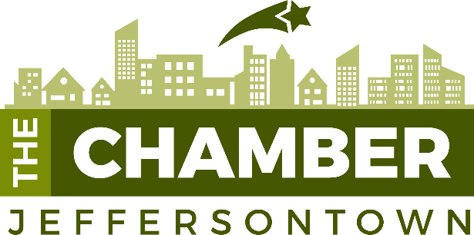

2021 Investor Leader Partnership Agreement Prepared for:
Primary Contact Information:
Contact Name: Greg Clark Title: Business Development Director
Company Name: Encore Wealth Management
Address, City, State, Zip 9405 Millbrook Road, Suite 101
Email: Thomas.clark@ampf.com Phone: 502-412-4050

As a Leader Investor in the Jeffersontown Chamber of Commerce, Encore Wealth agrees to pay $2,500 and be recognized as a Leader Investor.

Encore Wealth will provide:
- Logo/Artwork necessary for the Chamber for marketing purposes
- Contact/Representative for Chamber inquiries, information, or other needs/requests

The Jeffersontown Chamber will provide:
- Company logo on the website
- Two registrations for the following programs:
- Business Blasts
- Chamber Chats, A Speed Leads Event
- Annual Meeting
- Legislative Breakfast
- Gaslight Sponsorship Celebration
- Invitation to Top Investor events (at least 2 a year)
- Recognition as an investor on Chamber marketing materials
- One sponsorship opportunity at $150 - $250 level

______________________________________________________ __________________
Sponsor Representative Signature Date

______________________________________________________ __________________
Deana Epperly Karem Date
President & CEO
Jeffersontown Chamber of Commerce

